That’s the Ticket!

Interested in finding a job, but worried that it might affect your cash or medical benefits? Join us as Noble hosts

Work Incentives Seminar Event (WISE)

Wednesday, September 26
9:00 am, 11:00 am, or 1:00 pm (attend just one)
Irsay Family YMCA at CityWay
430 S. Alabama Street
Indianapolis, IN 46225

This FREE event for Social Security Disability Beneficiaries, their Families and other Ticket to Work community supporters will help you:
- Learn about myths related to Social Security Disability and work
- Find out how the Ticket to Work Program can help you
- Discover resources available on your path to work
Drawing for Door Prizes at Each Session. Walk away a Winner!

Register at:
http://www.mynoblelife.org/services/employment/ticket/wise
If you need transportation, an interpreter, or material in a different format, you must pre-register. You can also register by emailing Leigh Ann Lloyd at L.Lloyd@mynoblelife.org or calling/texting her at 502-216-0178.

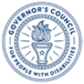
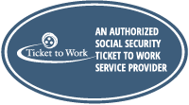
Sponsored by the Indiana Governor’s Council for People with Disabilities

